Type-C Mu/ti-Function Compact Docking Station
4K HMDI + 1 Port USB3.0 + PD Charge Port

C-TC-HDMI-USB3
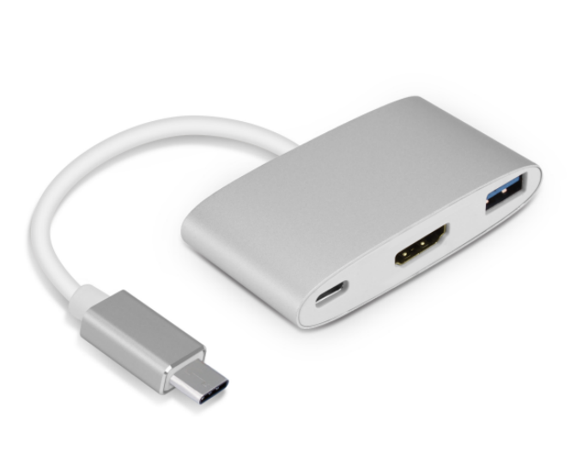

Descrption:
Ultra-compact, the must-have Type-C docking station for your Type-C MacBook ProTM, ChromeBook'M DellTM XPS and other notebook or desktop computers with the next generation Type-C ports.
Instantly connect an external 4K HDMI monitor, TV or projector for additional screens or desktop real-estate. Connect a USB keyboard or mouse at the same time as using the external HDMI screen.
And how about charging your USB Type C device, again use its built-in PD charge port simultaneously, all with the next-generation power of the Type-C interface on your notebook or desktop computer.

Features:

USB C HUB with Aluminum Alloy

Design oxidizing treatment surface and all the edges are high glossy finishing by CNC, makes this device elegant and shining.

Plug and Play

USB-C to HDMI Adapter convert your Type-C port to 1x USB 3.0 port, 1x HDMI video output port and 1x USB-C power charge port

4K HDMI ports

Type-C to HDMI adapter supports the video resolution up to 4K(3840X2160)@30HZ with the compatibility of most monitors, projectors, HDTVs and other devices with HDMI port. Make it easy to Launch a movie or shows on the phone or laptop to projectors, HDTVs and other devices with HDMI port

USB C Female Port

(PD/Power Delivery Charging Function): This USB-C Hub can charge your type-c host device via type-c power adapter while using the HDMI port and USB 3.0 port at the same time.

SPECIFICATIONS
- Shell:aluminum alloy
- Color:silver
- Interface: Type C (only Charg) + USB3.0 + HDMI interface performance
- Support system:IOS, WINDOWS, LINUX
- line length:10 ± 5mm
- Transfer speed:5Gbps
- Cable length: 150mm
- USB3.0 interface, 5V / 0.9A, 5GBPS transmission rate, backward compatible with USB2.0, plug and play
- HDMI interface, 3840 * 2160 @ 30Hz, plug and play
- TypeC interface, PD2.0 protocol
- Support system: IOS, WINDOWS, LINUX
- Applicable models: For APPLE full series of TYPEC interface computers (Xiaomi / Huawei / Samsung S8 mobile phone / Lenovo part notebook / HP notebook / GOOGLE notebook
- Other functions: support OTG

Product Code:
- Product net weight: 18g
- Product size: 43.2mm(L) x 36mm(W) x 12mm(H)
- Barcode: 8400800036551

